**Valve Closure Time**

There is currently a crude version which runs on VBA background and display results on Tables and Charts on an MS excel spread sheet

**Problem Statement:**

Presently in the Oil and Gas Industry the rule of thumb for the closure time of an Emergency Shut-down Valve (ESDV), is one second per inch in diameter. This translates to mean, it should take a second for the valves disc/ball port to transverse from fully open to fully close position in one second for a one-inch diameter valve.

However, we believe this is not accurate enough as prevailing operational conditions will affect the closure time of the valve. Such conditions of interest are the actual diameter of the valve, speed of the actuator, pressure of fluid being transported at that instant prior to rupture of pipeline and flow rate in a real-time situation.

We believe this actual operational hydrocarbon fluid parameters would have effect on the closure time of the emergency shutdown valve especially during emergency situations like, a pipeline rupture/leak.

**Objective:**

The main objective is to develop a programmable application (a web based friendly interface software), which can be used to model the closure time of Emergency shutdown valve and interaction with all HCR(Hydrocarbon Release) parameters. The model shall consist of numerical out-put calculations and line graphs itemising the relationship of Hydrocarbon fluid parameters (Pressure, Volumetric flow, Fluid velocity) with valve closure time.

**Algorithm:**

Please refer to the documents for Equations

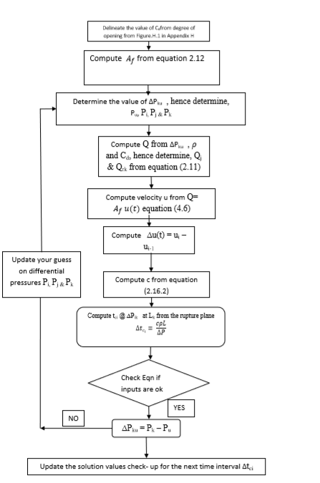

Q(t) =  (2.11)

(2.12)

(2.16.2)

Q (t) = Af(t) x u(t) (4.6)

Equation Parameters explained:

Q(t)= Volumetric Flow in m3/s at time t

u(t) = Fluid velocity at time t.

= coefficient of discharge at time t

= Valve flow area same as pipeline radius in (mm)

R = Radius of pipeline

X(t)= distance transverse by valve at time t

= Differential Pressure at upstream and downstream of valve at time t.

= Density of fluid

**Table:** **Showing HCR Inventory of 150mm ESDV**

|  |  |  |  |  |  |  |  |  |
| --- | --- | --- | --- | --- | --- | --- | --- | --- |
| X(t)(mm) | Cd | Ѳ | ∆P(bar) | Qi (m3/s) | Qj (kg/m3) | Qoutflow (m3/s) | ui(t) | ∆tci(s) |
| 0 | 1.00 | 90 | 205 | 5.155 | 3.686 | 0.023614 | 1.62063 | 0.00 |
| 15 | 0.90 | 80 | 138.29 | 4.344 | 2.685 | 0.457270 | 1.38424 | 0.68 |
| 30 | 0.75 | 70 | 93.96 | 3.582 | 1.866 | 0.919066 | 1.15713 | 1.35 |
| 45 | 0.58 | 60 | 63.61 | 2.742 | 1.309 | 1.176552 | 0.89841 | 2.03 |
| 60 | 0.40 | 50 | 43.06 | 1.874 | 0.931 | 1.150544 | 0.62259 | 2.71 |
| 75 | 0.30 | 40 | 29.15 | 1.393 | 0.673 | 1.003441 | 0.46952 | 3.39 |
| 90 | 0.20 | 30 | 19.74 | 0.2921 | 0.495 | 0.767648 | 0.31485 | 4.06 |
| 105 | 0.13 | 20 | 13.36 | 0.593 | 0.371 | 0.550832 | 0.20583 | 4.74 |
| 120 | 0.08 | 10 | 9.05 | 0.359 | 0.283 | 0.370591 | 0.12734 | 5.42 |
| 135 | 0.04 | 5 | 6.12 | 0.176 | 0.220 | 0.214988 | 0.06396 | 6.09 |
| 150 | 0.00 | 0 | 4.15 | 0 | 0.173 | 0.053862 | 0 | 6.43 |

**Excepted Output**

Table of values, line graphs and charts that shows the relationship between Hydrocarbon Fluid parameters with valve time of closure. Please refer to the spread sheet for examples of expected graphical output.

**Reference:**





<http://www.hse.gov.uk/research/rrpdf/rr1072.pdf>

<https://www.theiet.org/forums/forum/messageview.cfm?catid=205&threadid=102823>